**ML IA 2**

**Topic: Cryptocurrency price prediction**

Attached files:

* Model ipynb file
* pkl file
* Screenshots

Screenshot:

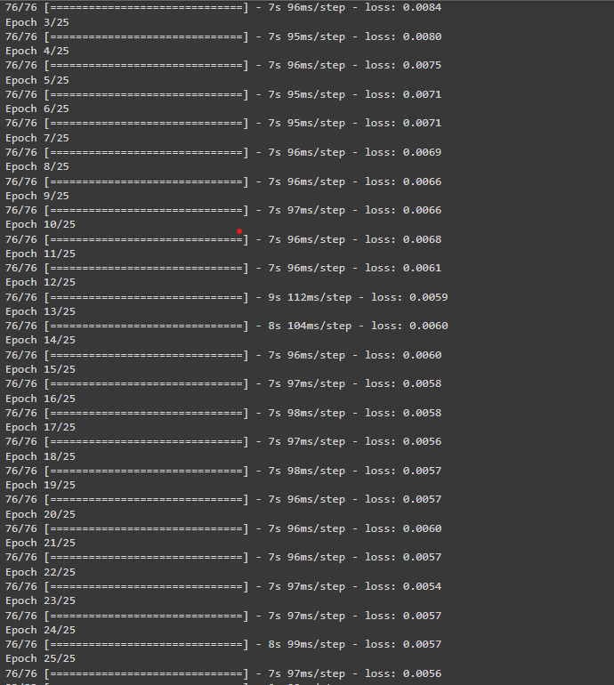

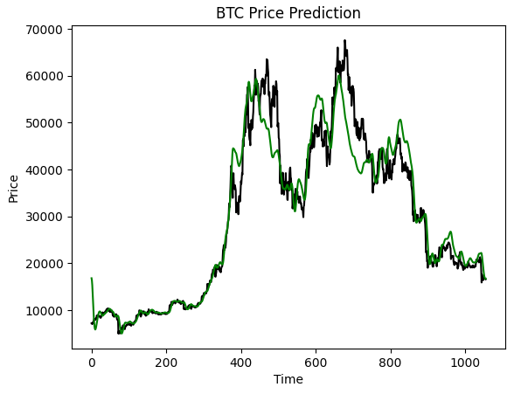

Black plot → Actual Price

Green plot → Predicted price

BTC price prediction:

